**How to run TestNG through Maven Command Line :**

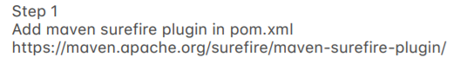

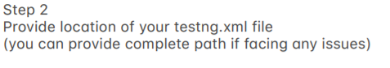

Add it in <**build**> tag outside <**dependencies**> tag.

In this we can provide the name of the testNG file to be run.

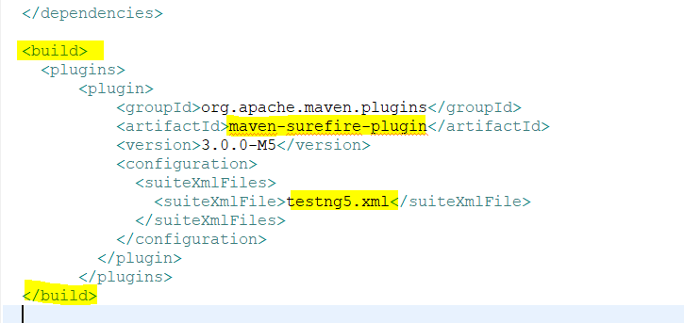

2. Open CMD and go to the location of the project.

Run the following command : **mvn clean test -Dtestng.dtd.http=true**

**‘-DvariableName=variableValue’** is used for providing any variable.

It will show the output like :

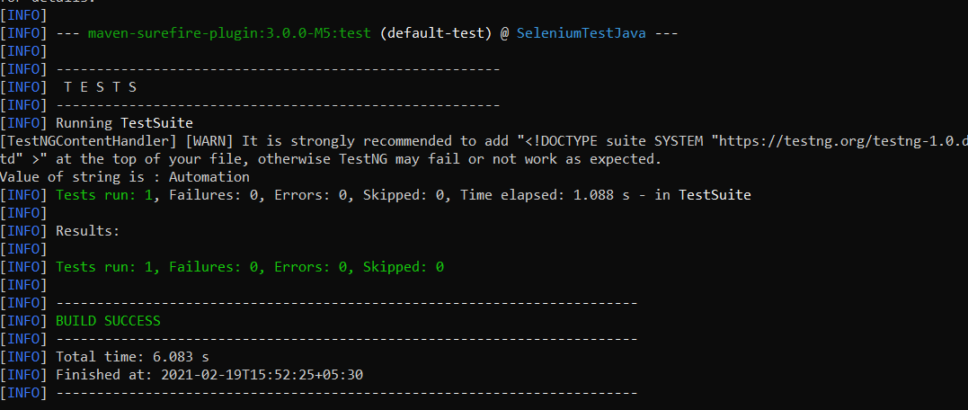

**How to provide testng.xml file name at runtime :**

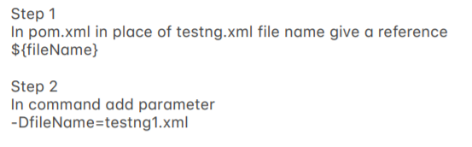

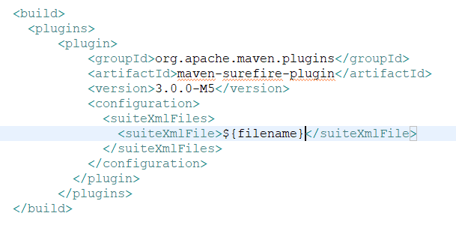

**Run the test using command :**

mvn clean test -Dtestng.dtd.http=true -Dfilename=testng5.xml

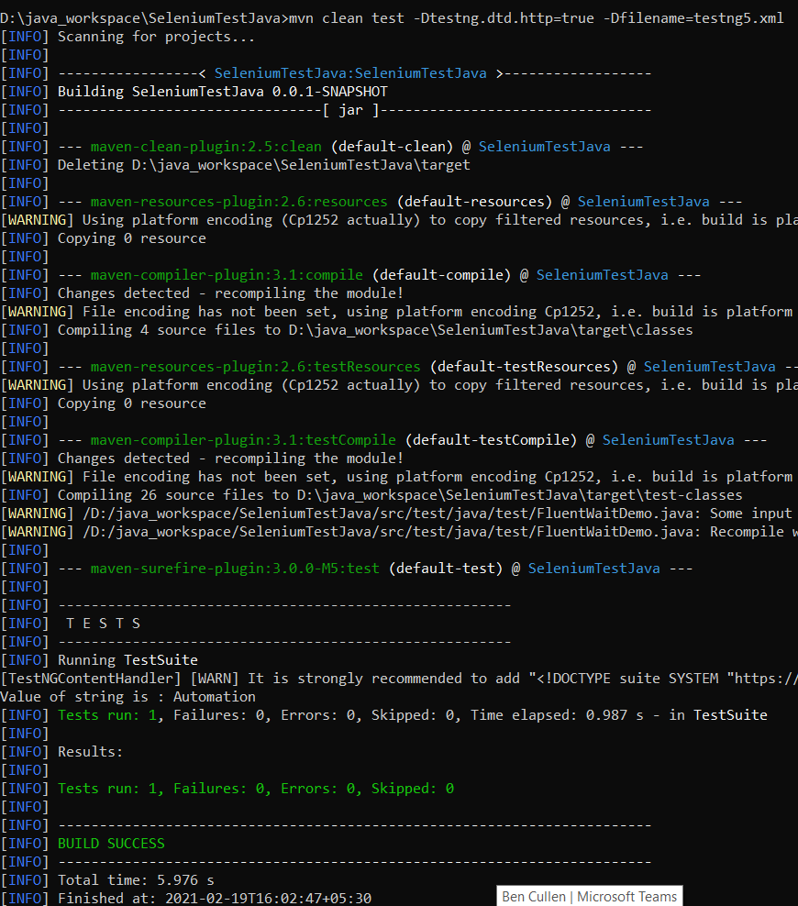



You can **directly specify the test/class** to be run in Maven-surefire plugin <configuration> tag using <**includes**> tag.

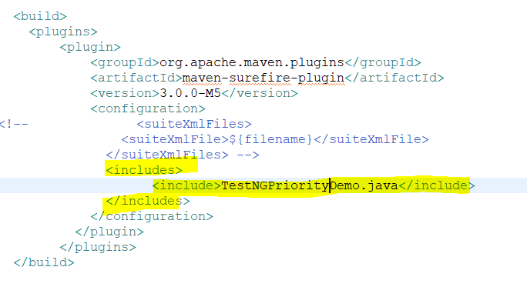

**Run from cmd like** : mvn clean test -Dtestng.dtd.http=true

This will run all the tests in the above-mentioned class.